Date of Damage: |  |  | Notes:  - Damage classification must be carried out by certified staff or approved maintenance organisation.  - In case of FRP-damages the damage classification must be carried out according to the latest revision of the Airplane Maintenance Manual, Section 51-10.  - In case of contact with salt water: Clean all mechanical parts within 48 hours after recovery from salt water.
AIRPLANE
Type:
Serial No.:
Call Sign:
TSN:
Operator: |  |  | Short description of damage(s), cause of damage / classification acc. to AMM, and reference for pictures :
ENGINE 1
Type:
Serial No.:
TSN:
TSO:
ENGINE 2
Type:
Serial No.:
TSN:
TSO:
PROPELLER 1
Type: |  |  | Statement:  I hereby declare that the damage(s) has(have) been classified acc. to AMM (section 51-10 for FRP damage)  and all relevant damages on the aircraft have been described.  (person / company / location):  -----------------------------------------------------------------------------------------------
Serial No.:
TSN:
TSO:
PROPELLER 2
Type:
Serial No.: |  |  | Date: |  | Stamp, Signature: |  | Page  of
TSN:
TSO: |  |  | Revision:
Note S/N of effected system parts on next pages

Position of damage(s):
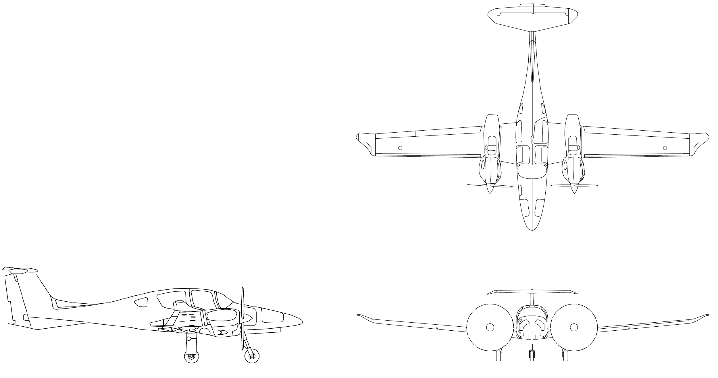
Date: |  | Stamp,  Signature: |  | Page  of
Revision:

Pos. | Detailed description / Size of Damage |  | Classification | Reference to attached Picture(s) |  | Proposed Repair
Date: |  |  | Stamp,  Signature: |  |  |  | Page  of
Revision:

Pos. | Detailed description / Size of Damage |  | Classification | Reference to attached Picture(s) |  | Proposed Repair
Date: |  |  | Stamp,  Signature: |  |  |  | Page  of
Revision:

Pos. | Detailed description / Size of Damage |  | Classification | Reference to attached Picture(s) |  | Proposed Repair
Date: |  |  | Stamp,  Signature: |  |  |  | Page  of
Revision:

Pos. | Detailed description / Size of Damage |  | Classification | Reference to attached Picture(s) |  | Proposed Repair
Date: |  |  | Stamp,  Signature: |  |  |  | Page  of
Revision:

