Date of damage: |  |  |  | Notes:  - Damage classification must be carried out by certified staff or approved maintenance organisation.  - In case of FRP-damages the damage classification must be carried out according to the Airplane Maintenance Manual. For HK36, Section 5.2.1, latest revision and for H36, Section 8, latest revision.  - In case of contact with salt water: Clean all mechanical parts within 48 hours after recovery from salt water.  - Submit the complete form via Diamond Partner Portal (https://partners.diamondaircraft.com/s/ ) or  via Service Center Network (https://www.diamondaircraft.com/en/service-and-support/service-center-locations/ )
AIRPLANE
Type:
Serial No.:
Call Sign:
TSN:
Operator: |  |  |  | Short description of damage(s), cause of damage / classification acc. to AMM, reference for pictures :
ENGINE
Type:
Serial No.:
TSN:
TSO:
PROPELLER
Type:
Serial No.:
TSN:
TSO:
SN of effected system parts: note on further pages
Statement:
I hereby declare that the damage(s) has(have) been classified acc. to AMM (HK36 / Section 5.2.1; H36 / Section 8 - for FRP damage) and all relevant
damages on the aircraft have been described.

(certifying staff / company / location):
---------------------------------------------------------------------------------------------------------------------------------------------

Date: |  |  |  |  | Stamp, Signature: |  | Page  of
Revision:

Position of damage(s) H36 / HK36 R / HK36 TS / HK36 TTS: |  |  | Position of damage(s) HK36 TC (-100) / HK36 TTC (-ECO):
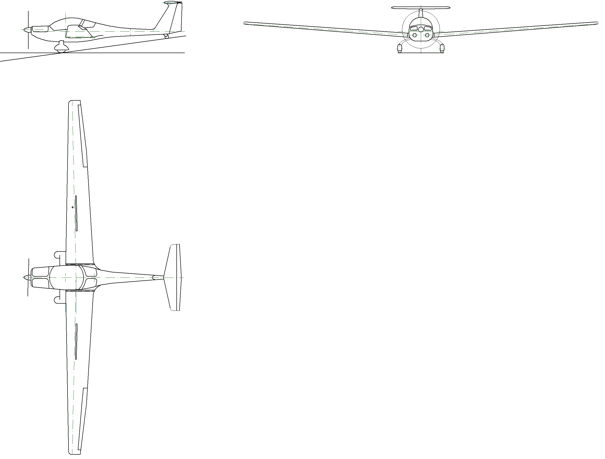 |  |  | 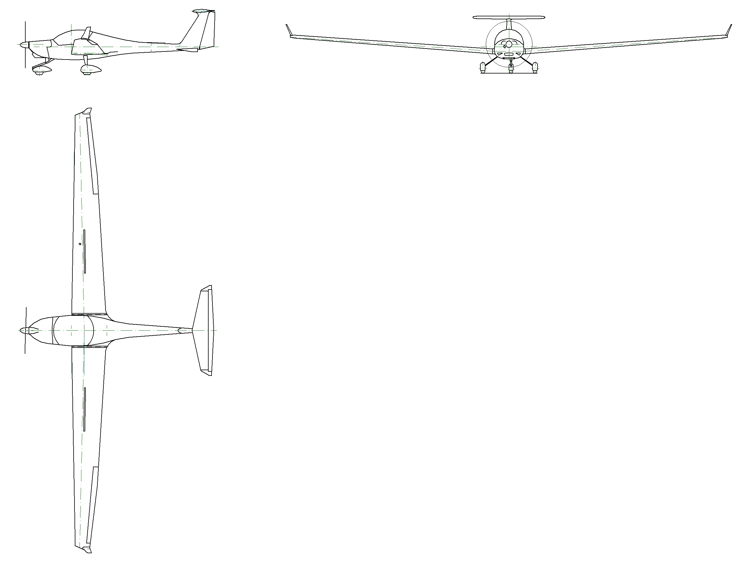
Date: |  | Stamp,  Signature: |  |  | Page  of
Revision:

Repair/Change History

List all repairs in the damaged area that existed before the damage and all non-TC Holder changes and STCs in this table to be considered in the repair design.
Append the complete documentation to this damage report..
Pos. | Reference to  non-TC Holder Design Change/ STC/ repair |  |  | Detailed description
Date: |  |  | Stamp,  Signature: |  |  | Page  of

Damage Description

Pos. | Detailed description / Size of Damage |  | Classification |  | Reference to attached pictures |  | Proposed Repair
Date: |  |  |  | Stamp,  Signature: |  |  |  | Page  of
Revision:
Pos. | Detailed description / Size of Damage |  | Classification |  | Reference to attached pictures |  | Proposed Repair
Date: |  |  |  | Stamp,  Signature: |  |  |  | Page  of
Revision:

Pos. | Detailed description / Size of Damage |  | Classification |  | Reference to attached pictures |  | Proposed Repair
Date: |  |  |  | Stamp,  Signature: |  |  |  | Page  of
Revision:
Pos. | Detailed description / Size of Damage |  | Classification |  | Reference to attached pictures |  | Proposed Repair
Date: |  |  |  | Stamp,  Signature: |  |  |  | Page  of
Revision:
Pos. | Detailed description / Size of Damage |  | Classification |  | Reference to attached pictures |  | Proposed Repair
Date: |  |  |  | Stamp,  Signature: |  |  |  | Page  of
Revision:
Pos. | Detailed description / Size of Damage |  | Classification |  | Reference to attached pictures |  | Proposed Repair
Date: |  |  |  | Stamp,  Signature: |  |  |  | Page  of
Revision:
Pos. | Detailed description / Size of Damage |  | Classification |  | Reference to attached pictures |  | Proposed Repair
Date: |  |  |  | Stamp,  Signature: |  |  |  | Page  of
Revision:
Pos. | Detailed description / Size of Damage |  | Classification |  | Reference to attached pictures |  | Proposed Repair
Date: |  |  |  | Stamp,  Signature: |  |  |  | Page  of
Revision:

