Date of damage: |  |  |  | Notes:  a) Damage classification must be done by a certified staff or an approved maintenance organisation.  b) In case of FRP-damages the damage classification must be carried out according to the Airplane  Maintenance Manual, Section 51-10, latest revision.  c) In case of contact with salt water: Clean all mechanical parts within 48 hours after recovery from salt water.  d) Submit the complete form via Diamond Partner Portal (https://partners.diamondaircraft.com/s/ ) or  via Service Center Network (https://www.diamondaircraft.com/en/service-and-support/service-center-locations/ )
AIRPLANE
Type:
Serial No.:
Call Sign:
TSN:
Operator: |  |  |  | Short description of damage(s), cause of damage / classification acc. to AMM, reference for pictures:
ENGINE
Type:
Serial No.:
TSN:
TSO:
PROPELLER
Type:
Serial No.:
TSN:
TSO:
SN of effected system parts: note on further pages
Statement:
I hereby declare that the damage(s) has(have) been classified acc. to AMM (section 51-10 for FRP damage) and all relevant damages on the aircraft have been described.

(person / company / location):
--------------------------------------------------------------------------------------------------------------------------------------------------------------
Date: |  |  |  |  | Stamp, Signature: |  | Page  of
Revision:

Position of damage(s):

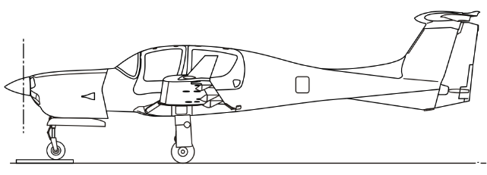

Date: |  | Stamp,  Signature: |  | Page  of
Revision:

Pos. | Detailed description / Size of Damage |  | Classification |  | Reference to attached pictures |  | Proposed Repair
Date: |  |  |  | Stamp,  Signature: |  |  |  | Page  of
Revision:

Pos. | Detailed description / Size of Damage |  | Classification |  | Reference to attached pictures |  | Proposed Repair
Date: |  |  |  | Stamp,  Signature: |  |  |  | Page  of
Revision:

Pos. | Detailed description / Size of Damage |  | Classification |  | Reference to attached pictures |  | Proposed Repair
Date: |  |  |  | Stamp,  Signature: |  |  |  | Page  of
Revision:

Pos. | Detailed description / Size of Damage |  | Classification |  | Reference to attached pictures |  | Proposed Repair
Date: |  |  |  | Stamp,  Signature: |  |  |  | Page  of
Revision:

Pos. | Detailed description / Size of Damage |  | Classification |  | Reference to attached pictures |  | Proposed Repair
Date: |  |  |  | Stamp,  Signature: |  |  |  | Page  of
Revision:

Pos. | Detailed description / Size of Damage |  | Classification |  | Reference to attached pictures |  | Proposed Repair
Date: |  |  |  | Stamp,  Signature: |  |  |  | Page  of
Revision:

Pos. | Detailed description / Size of Damage |  | Classification |  | Reference to attached pictures |  | Proposed Repair
Date: |  |  |  | Stamp,  Signature: |  |  |  | Page  of
Revision:

Pos. | Detailed description / Size of Damage |  | Classification |  | Reference to attached pictures |  | Proposed Repair
Date: |  |  |  | Stamp,  Signature: |  |  |  | Page  of
Revision:

